10
The impacts of COVID-19 March/April 2020

5 - 7 Montgomery St Lane,
Edinburgh, EH7 5JT, UK

t: +44 (0)131 281 0897
e: admin@intdevalliance.scot
w: www.intdevalliance.scot

Lorem ipsum dolor sit amet

Lorem ipsum dolor sit amet

Lorem ipsum dolor sit amet

subtitle (if needed)

subtitle (if needed)

subtitle (if needed)

Who we are

Scotland’s International Development Alliance (the Alliance) is the membership body in Scotland for everyone committed to creating a fairer world, free from poverty, injustice and environmental threats. Our membership brings together a diverse range of organisations and individuals including over 160 NGOs, businesses, academic institutions and public sector bodies that operate in over 100 countries.

Key findings

- The loss of charitable funding has hit the sector hard. This has serious implications for almost all our members and threatens the very future of some.

- Flexibility from donors is of great significance to members with institutional funding.

- The situation in partner countries varies considerably. Some are in lockdown, some are not. There are widespread concerns about the inability of public health systems to cope should the pandemic take a similar course to that in Europe and North America. There are general expectations of a deepening of poverty and some mention the likelihood of increased starvation.

- The Alliance is asked to help with advocacy and by providing more opportunities for information sharing.

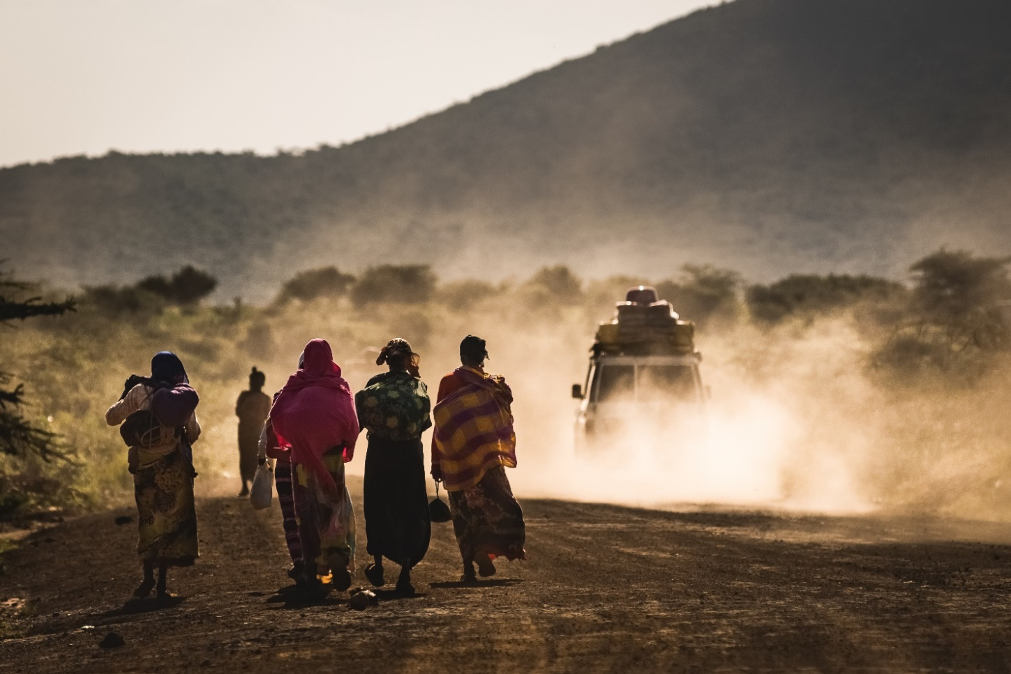

Contents
Key findings 2
Introduction 4
The impact in Scotland 5
The impact in programme countries 6
How donors and fund managers are responding 7
What organisations are asking for 8
Recommendations 9
Annex 10
Survey One: Member survey 10
Survey Two: Alliance Community poll 11
Survey Three: Webinar on COVID-19 12
Survey Four: Phone consultations with members 14

Introduction

The Alliance is well-placed to gather up evidence on the effect of the COVID-19 pandemic, here in Scotland, and the threatened pandemic in the countries around the world where our members work. Information offered up by our members, drawn together, anonymised and analysed, gives us a vivid and useful snapshot of this fast-moving crisis.

The research was undertaken very fast, using mixed methods, through: three quantitative surveys (an annual membership survey issued on 1 April, two polls taken during a COVID-19 webinar on 14 April and an Alliance Community poll open from 24 March) and one qualitative semi-structured survey (14 phone interviews conducted between 9 and 24 April).

The research was designed to improve our understanding of the impact of the pandemic and to produce findings which are helpful to:

- our members themselves, as they plan their own responses,
“There is a lot of concern about healthcare systems and their ability to cope”

- Alliance Board and staff, as we seek to respond as effectively as we can to our members, and
- other stakeholders with interests in supporting the sector in Scotland and our partners in the global south.

We owe a big vote of thanks to the seventy-two organisations and individuals (33% of our organisational membership) who responded to us at a very difficult time.

In this summary report we set out the key findings of the research; then summarise information from each of the sections which we covered in our questionnaires and phone interviews:

- the impact in Scotland;
- the impact in programme countries;
- how donors are responding;
- and the requests for actions by the Alliance.

We finish with two recommendations and a pledge to take forward where possible the actions requested of us by our members.

Survey questions and anonymised responses are presented in the annex at the end of this report.

The impact in Scotland

- Restrictions on UK travel is the challenge most often mentioned in the membership survey

- Two medium sized charities predicted a loss of community fundraising/events income in the region of £4,000 for the first quarter, and a very small charity cited the loss of predicted income of £30,000 for one event.

- At least 8 members (mainly larger organisations) have staff on furlough, with one other member looking at the options of furloughing compared to reducing salaries

- Some positives impacts e.g. some cited an increase in one-off donations or digital challenges/fundraising events; some donors are being reassuring; trusts/foundations are being flexible and there were expressions of solidarity and offers of help from partners

- The impact of working from home is felt by all but less for those who are used to working remotely or for volunteer-led organisations who have never had an office

- The challenges of narrative around 0.7% of national income for aid and public support for international aid, especially at this time of crisis at home.

The impact in programme countries

The risk of COVID-19 outbreaks and lockdown
- “Really terrible situation, lack of information, peoples’ awareness is really low in terms of the danger of the virus.”
- “In Africa the cases are generally low, but they will catch up”.
- “Tanzania….in a lot of trouble. We think the country is going to be hit very badly by the virus and economically.”
- “Nigeria is still trying to work, but the university is closed. Big issues there. Partners in India and Ghana have closed buildings and labs.”
- “We hear that in some areas lockdown measures have been extreme, levels of force and violence used way beyond proportionate.”
- “The school in Uganda- they can't go out. We didn't hear that the funds we sent had arrived, which made me nervous, but there had been power cuts and therefore no internet and they couldn't get to the bank.”
- “People think that the [Malawi] government’s messaging around Covid-19 is just a way of avoiding another election.”
- “Faith-based leaders don’t always understand the situation, and might just think ‘God will protect us’.”

Welfare and healthcare systems
- “The way the country is, you would expect a lot of cases and a lot of deaths due to poverty and access to healthcare”
- “People are living from hand to mouth, there is no government support as there is here”
- “There is a lot of concern about healthcare systems and their ability to cope”.
- We have encouraged partners to investigate what role they can play in local response (e.g. involvement in public health campaigns, etc)

Safeguarding and gender-based violence
- “Sexual and gender-based violence is something we have been working on for some time now and this is something that will be a focus for us, as COVID-19 will exacerbate the issues”.
- “Safeguarding incidents are likely to increase, especially for our main beneficiaries which are girls.”
- “Women and children will be at risk during a stressful situation.”

Access to food and agriculture
- “Risks of starvation may be more acute than risks from the virus, which is considered as very likely to take a real hold and become widespread.”
- “This is a key time in the agricultural calendar, and from what we’ve heard, planting did take place at the start of the year. But now they can’t access fields, fertilisers etc., and that will have an impact on future yields.”
- in Malawi – there are issues about how to get food, how to get water, so individuals are then faced with other issues such as extreme poverty.
- “In Malawi put food first. Support should be directed to keep people from starvation.”

Requests for funds
- “We have been inundated with emergency requests for support. Our Board has released £1m from reserves to fund this emergency”.
- “We are scratching around to support them. We can't stop.”

(Examples taken from phone interviews)

How donors and fund managers are responding

The Alliance held an invitation only roundtable for eight funders and donors. on 21 April, below is a summary of member comments on the main institutional donors active in Scotland:

- Scottish Government - widely welcomed commitment to the next instalment of funds (six months from 1 April for main grant holders, one year for small grants, but with a review in June/July). Grantees cite problems of not allowing for repurposing or pivoting grants to COVID-19; with some complaints around lack of information received (e.g. only travel advice on Malawi) and complaints around the approach to risk registers being more like a scenario planning exercise. There is uncertainty around any intentions of demands for return of underspends without review of proposals for alternative spend.

- DFID - being flexible with rescheduling activities and extending deadlines where appropriate. Grantees are seeking reassurance on paying staff salaries where in-country activities have been paused. Grantees are invited to discuss pivoting programmes to COVID-19 with their Senior Responsible Owner, decisions are taken on case-by-case basis. Secretary of State letter 1 May 2020 sets out ‘pragmatic and sensible’ measures to help civil society organisations maintain delivery of essential programmes including where necessary altering milestones, adjusting workplans and offer support for continued cash flow where programmes are paused. See letter here.

- Corra Foundation - has been praised for their reassuring approach and offer of additional £500 micro-grants to existing Scottish Government grantees, but there have been complaints about the lack of flexibility around the capital spend restrictions on the Climate Justice Innovation Fund which prevents a pivot to COVID-19 activities e.g. handwashing and water provision.

- Donors and foundations praised as supportive and flexible - Jersey Government, Hewlett Packard Foundation, Comic Relief, DFID, Scottish Government and the Corra Foundation.

What organisations are asking for

- At least 9 members have asked about funds available such as resilience funds similar for the domestic sector, to be made available for the international sector, ranging from small charities who suggest £1000 would be enough to very large charities. Can the Alliance advocate for resilience funds for international NGOs?

- Request to Scottish Government to convene a grantee meeting.

- Set up country cluster and themed groups.

- Continue to provide dialogue spaces.

- Advocate with funders for flexibility in adapting programme spend in the face of a changed reality on the ground e.g. to give permission to programme partners to use grants in response to more urgent needs.

- “Advice to charities working on projects with partners abroad as to how to continue their work in the present crisis with little income but significant on-going expenses. There are funds available for charities working in the UK but a note of possible funding sources for charities working abroad would be very helpful."

- "It would be great to have links to emergency Covid19 funding."

Recommendations

The pandemic has moved very fast in countries in Asia, Europe and North America, from the time of the first recorded infections to the first signs of the rate of daily fatalities starting to peak and lessen.

The threat of humanitarian tragedy of catastrophic proportions looms in the global south, where public health services and government financial support for individuals and businesses are not comparable to those in much wealthier societies.

We recommend therefore that urgent priority must be given to invite and support proposals for preventive and mitigating actions while this brief window exists, before the pandemic takes hold in the global south.

We recommend a second survey is undertaken in three months. An update on the situation will be needed in this fast moving scenario to inform the best possible way that the international sector in Scotland can work with its partners in the global south.

We recommend that the Alliance membership and key stakeholders in Scotland, especially Government, come together urgently to discuss and decide how best we can maximise our collective strengths to respond with our full capacity to the needs of our partners in the global south.

It is the time for Scotland’s role as a good global citizen to be put to the greatest test of this generation.

Annex

Survey One: Member survey

- Sent to all 167 organisational members and 54 individual members on 1st April 2020
- 44 responses, Represents 20 % of the overall membership
  - 1 from an individual member
  - 29 from NGOs
  - 2 from private sector
  - 5 from academic or research orgs
  - 6 trusts or foundations

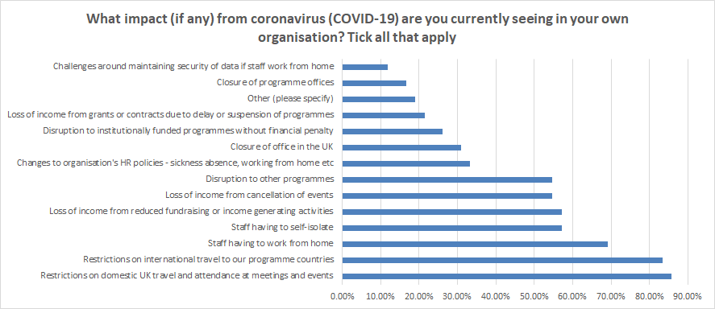

- All options were chosen at least once

- Most often chosen impacts are unsurprisingly around travel and homeworking (but more people chose that reduced income from fundraising was affecting them compared to staff having to self-isolate)

- Funding & income & institutional programme disruption were key themes

- Comparatively least often chosen impacts group around logistics of data security and closures or UK/programme offices and HR (but this might be due to the survey being issued in early April and certainly member surveys and experiences during the webinar suggested data connectivity and internet access in-country and not having the resources to work from home will be challenging)

Qualitative answers to the ‘other’ question, show the array of impacts of different types of organisation:
Size of organisation | Response
Very small NGO | We are a small volunteer-led NGO with no paid staff. Coronavirus will have a huge effect on us if any of us are affected and we are already having to delay programme implementation in Zambia.
Very small NGO | our implementing partner in Liberia has some area-based restrictions which may affect the school building programme
Very small NGO | We are all volunteers. There is therefore no salary loss but loss of funds for our project because events cannot take place.
Small NGO | Re-budgeting our work so that we can ask donor for changes to pivot our project towards responding to COVID-19
Trust/ Foundation member | Challenges getting formal processes / decisions confirmed
Medium sized NGO | Increased demands on funding due to hunger in countries with lockdown where population has no safety net and demands for hospital equipment due to virus
Large NGO | Inability to send grants to partners. Inability to respond to new partner request

Questions about funding from further open question about support from Alliance requested:

" Advice to charities working on projects with partners abroad as to how to continue their work in the present crisis with little income but significant on-going expenses. There are funds available for charities working in the UK but a note of possible funding sources for charities working abroad would be very helpful."

"It would be great to have links to emergency Covid19 funding."

Survey Two: Alliance Community poll

- Published on the 24 March 2020
- 7 respondents with 43 different votes
- Most cited other than the difficulty of travel and ban on large gatherings within countries was the challenge of delaying field visits and difficulties of any future planning

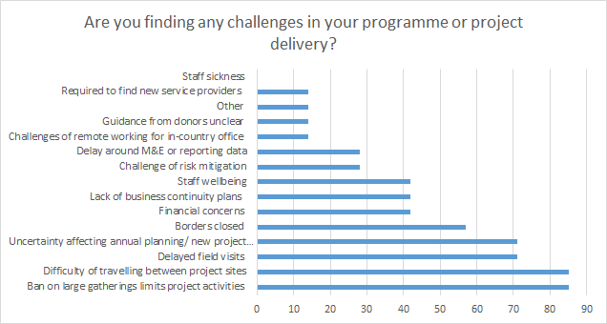

Survey Three: Webinar on COVID-19

- Held on the 14 April 2020 using two polls
- There were some positive impacts conveyed but also negative impacts
- Themes:
  - delay to collecting data and reporting expected next year;
  - uncertainty;
  - seeking reassurance on legalities and ethics of using reserves;
  - questions of keeping staff on in-country where programme activities are paused;
  - challenge of communicating with partners e.g. slowing communications or challenge of connectivity ;
  - Also concerns over worsening inequalities and heightened need in programme countries.
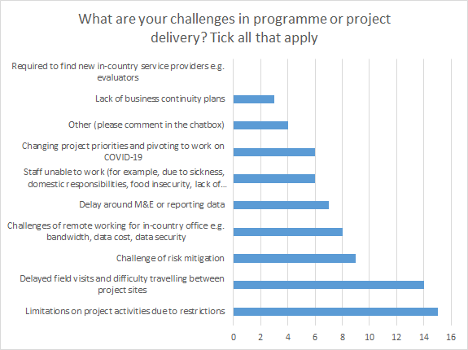

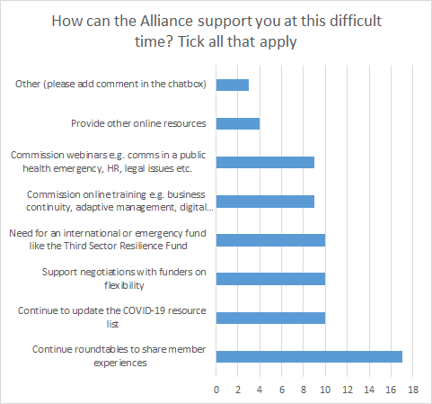

Survey Four: Phone consultations with members

- So far 14 interviews have been held, with small to large organisations, some with institutional funding and some without, one of which is a funder, and one individual member.

- Semi-structured interviews were conducted with ten questions:

Questionnaire, for semi-structured interviews

Introduction (Qs 1-3)

Our questions fall into 2 parts, the effect of COVID-19 on your organisation here in Scotland and on your work overseas. Purpose of research. Use of findings. Anonymity.

Here in Scotland:

What is the impact of the virus on your organisation here at home? Consider:

Q4

- human resource (staff absences sick leave, furlough, paid off);
- physical effects of lockdown (ability to travel, procurement, your suppliers, remote working, internet access)

Q5

- funding; charitable fundraising from the public; corporates, trusts and foundations, institutional, eg Scottish Government, DFID, EU.

Overseas:

Q6

Colleagues in branch/associate offices (if applicable); and/or partner organisations

Q7

- human resource
- physical effects of lockdown
- funding; as implementing partners of your grants you manage here in Scotland, and more generally.
- anticipated ability to deliver their programmes for which you channel funding.
- have you had conversations with your partner about re-orientating programme activities in face of COVID-19 to better meet needs of beneficiaries? If yes, please summarise.

Q8

Broader contexts overseas
Information passed to you by your colleagues and/or partner organisations about local conditions now, and anticipated in the near future, in which country(ies) and region(s).

Q9
How can Alliance support you in your response to COVID-19

Q10
Other.

Placeholder for logo.
Delete as appropriate.
Placeholder for logo.
Delete as appropriate.
Placeholder for logo.
Delete as appropriate.
Placeholder for logo.
Delete as appropriate.
5 - 7 Montgomery St Lane,
Edinburgh, EH7 5JT, UK

t: +44 (0)131 281 0897
e: admin@intdevalliance.scot
w: www.intdevalliance.scot

